**WELCOME TO GIVE BIRTH**



**It is time to leave for the hospital**

* when contractions become regular (every 5-10 minutes), have continued for about two hours and are painful, intensifying all the time
* when the amniotic fluid breaks, even if you do not have contractions, contact the maternity ward to decide when you need to come to the hospital
* if you have clear bloody discharge, call an ambulance to get to the hospital (at the end of the pregnancy, bloody mucus, called a mucus plug, may come away from your uterus, and if that is the case, you can still wait at home)
* when you have persistent severe pain in your abdomen

Your sensations at the onset of labour may wary. You can call the maternity ward and ask for advice tel. 040 1533247

**How do I get to the hospital?**

The hospital door F1 is intended for e.g. those coming to give birth. The door is open   
from 6 am to 8 pm on weekdays and from 7 am to 8 pm on weekends. At other times,   
ring the doorbell to the left of the main door.

Sotkamontie 13 from 22 January 2020 onwards

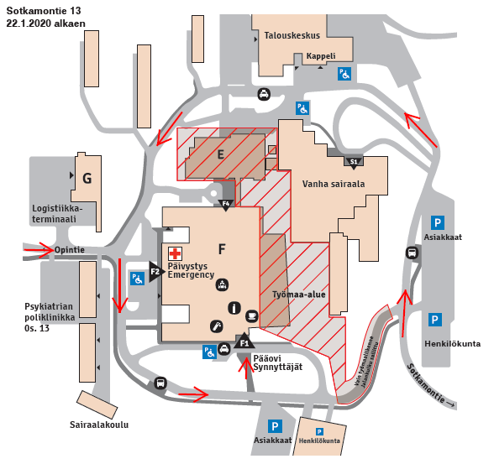

Customers

Parking

Staff

Customers

Staff

Parking

Main door  
Entrance to oabour ward

Chapel

Hospital school

Building site

Old hospital

Clinic of psychiatry os 13 os

Logistics terminal terminal

Maintenance building

**A future support person or father**

The spouse or support person creates a sense of security during childbirth and reassures and encourages the mother.

The spouse or support person can rub the mother’s back, help her change position, and give her a drink or just hold her hand.

The most important thing is just to be present.

However, it is not always possible for a spouse or support person to attend. In this case the midwife will try to spend more time with the mother.

**What can the mother bring to the maternity ward?**

* personal hygiene items
* own medicines (e.g. asthma inhalers)
* own slippers

**What can the father / support person bring to the maternity ward?**

* Bring comfortable clothes and your own slippers.
* Bring a snack for yourself. There is a refrigerator and microwave in the family ward. You can also order lunch and dinner for a separate fee
* Mobile phones and other electronic devices may be used. However, remember that after the birth, your baby needs all your attention!

**Childbirth**

Giving birth is a special and unique experience for every woman. The most important thing is not giving birth without pain, but the fact that the woman feels that her wishes and needs are heard and respected during labour. There may be unexpected twists, and for that reason, keeping an open mind is important during childbirth. You can express your wishes in the preliminary information form you send to the hospital beforehand, and during labour.

**Labour can be divided into three stages**:

* opening
* delivery of the baby (pushing)
* delivery of the placenta

During the *opening stage,* the cervix dilates to 10 cm with the help of contractions. Pain during contractions is not dangerous, it is a sign of the progression of labour. The pain comes in waves, its intensity rising and decreasing rhythmically. The pain is followed by relief.

The mother can relieve her labour pains with various relaxation positions that are worth practicing in advance. When the mother concentrates on relaxing her body and observing her breathing, the focus turns away from the pain. Massaging, stroking, and touching can also help her relax during labour.

The mother’s position and movements play a major role in her experience of labour pain and the progression of labour. They help the baby descend in the pelvic cavity and to settle in the right position. Sitting /swinging on a gym ball, using a yoga hammock, or a warm or cold grain bag or gel bag may alleviate the pain. Shower, bathing, or sauna may also help relax.

If you wish, you may ask for acupuncture treatment during different stages of childbirth. It can have an effect on labour pains, on delivering the placenta, and on helping milk come in after giving birth. You can also try the TENS machine or sterile water injections to relieve pain.

Laughing gas may help contraction pains. It is easily available, and the effects are not long-lasting.

You can relieve labour pains with an intramuscular pain relief injection as well as with various types of anaesthesia, e.g. epidural, spinal, and cervical anaesthesia.

Once the cervix is fully dilated and you are allowed to push, you can try different *pushing positions*. These include e.g.

* a half-sitting position on the maternity bed
* on your side
* on all fours
* sitting on a stool
* giving birth in water (if you meet the criteria)

During the *delivery of the placenta* the midwife may press on your stomach to advance the placenta forward, and the placenta is usually delivered within one hour after having your baby. Sometimes the placenta is not delivered, and it must be removed by hands. An obstetrician will remove the placenta in an operating room next to the maternity ward while the mother is under local or general anaesthesia.

Sometimes the method of delivery is a Caesarean section, for reasons relating to the mother or the baby. The father can usually attend the operation and/or participate in taking care of the baby.

**After birth**

When the baby is born, the mother will get it on her skin. The most acute senses of a baby are touch and smell. It is possible to start breastfeeding immediately. If the mother is unable to take the baby on her skin for some reason, the father can provide skin contact for the baby. This will give the baby a sense of security.

The baby is weighed and measured in the family ward. The family moves to the family ward about three hours after giving birth. We will discuss the childbirth with you before you are released from the hospital.

**MC900397354[1]In the family ward**

In the ward, the baby is roomed-in around the clock. The staff will guide and advise you on baby care and breastfeeding. Rooming-in promotes successful breastfeeding and the interaction between parents and the baby. Siblings and grandparents are welcome to the ward to visit the family. Preferably only one set of guests at a time. During infection seasons, restrictions on visits may apply. Please check any restrictions before your guests arrive.



The baby will be examined by a paediatrician at about two days of age.

The family can go home when the mother and baby are well. You can also give birth as an outpatient and be discharged from the hospital early, within 12-36 hours after giving birth, if the criteria are met. Please tell us about your wishes at the latest while giving birth.

**Pelvic floor exercises**

While in the ward, you have the opportunity to receive guidance and instructions on postpartum pelvic floor muscle exercises and on starting exercise after childbirth. Ask the ward staff for instructions.

**Contact details**

Family ward

Sotkamontie 13, building F1, floor 3, 87300 Kajaani

Phone 040 1533247 maternity ward

Phone 044 7974612 family ward

**Links**

<https://sote.kainuu.fi/palvelut/hoito-raskauden-aikana-ja-synnytys>

<https://fi-fi.facebook.com/synnytakajaanissa>

<https://podtail.com/fi/podcast/sydanaania/synnytykseen-valmistautuminen-osa-1>

<https://www.youtube.com/watch?v=j14gyCGXsXk> (presentation video)

Welcome to give birth!