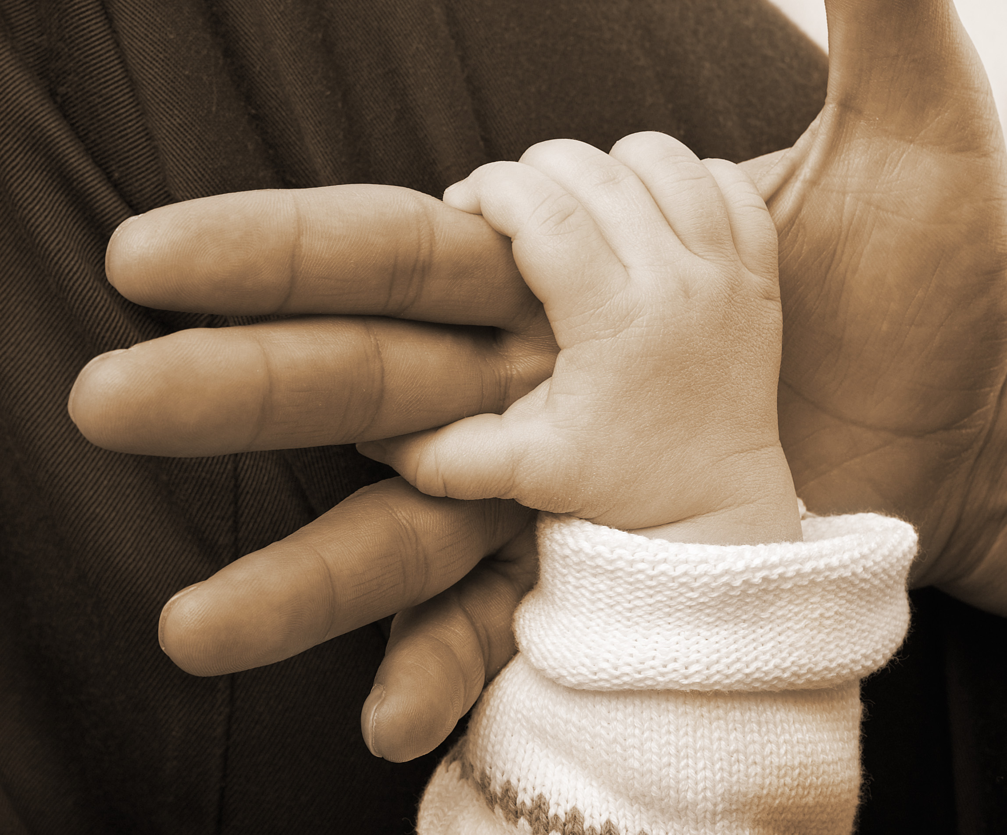



khvaperhetyojakotipalvelu

Family work

Professional family work for families with children is a social service in accordance with the Social Welfare Act (1301/2014, section 18). Family work offers dialogue and guidance in matters related to parenting and everyday life. Family work aims to strengthen families’ capacities and interaction skills. Family work is goal-oriented and systematic, and the aim is to strengthen the coping methods and internal resources of families, as well as to ensure coping in everyday life.

The work is carried out mainly in the homes of families. Family work is confidential and its duration depends on the needs of each family. Visits are planned and agreed in advance with each family.

The aim of family work is to offer support to families with children as early as possible. The granting of family work does not require being a child welfare client.

Family work provides help in the following areas:
- parenting
- growth and development of children and young people
- coping in everyday life
- family interaction skills
- strengthening of a family’s capacities

In family work, the most important methods include talking and working together. In addition to guidance and modelling, if necessary, family work may sometimes include assessment forms, cards, role maps and networking.

Family work emphasises cooperation with parents. However, family work can also be based on one-on-one work with a child if this is seen to help the parents and increase the family's ability to function.

Applying for family services in municipalities inside the Kainuu wellbeing services county:

You may apply for family services by filling out an electronic form at omasote, by filling out a printable form, or by contacting the family work social instructor.

To apply for family services of the Kainuu wellbeing services county or to find out more information, please visit: https://hyvinvointialue.kainuu.fi/perhetyo

Paper applications must be sent to:

Kainuun hyvinvointialue / Kotona asumista tukevat palvelut
Family services social instructor
Kajaanin perhekeskus
Lönnrotinkatu 2 C, 87100 Kajaani

Family services social instructor
tel. 044-797 4878

For more information, please also visit:
https://thl.fi/fi/aiheet/lapset-nuoret-ja-perheet/sote-palvelut/sosiaalipalvelut/perhetyo

